Practical No.3
Write a Program to implement web Service to Convert Currency from Rupees to Dollar. Use following formula for conversion
Conversion Rate: 1 USD = 75 INR
Deploy the above Web service properly and call it by designing appropriate interface in .NET. / JAVA

Server-Side Code:-
package server;
import javax.jws.WebService;
import javax.jws.WebMethod;
import javax.jws.WebParam;
@WebService(serviceName = "CCWS")
public class CCWS {
@WebMethod(operationName = "INR2Dollar")
public double INR2Dollar(@WebParam(name = "rs") double rs) {
return (rs / 75);
}
@WebMethod(operationName = "Dollar2INR")
public double Dollar2INR(@WebParam(name = "dollar") double dollar)
return(dollar * 75);
}
Output:- 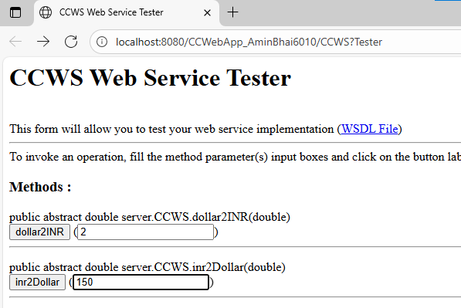

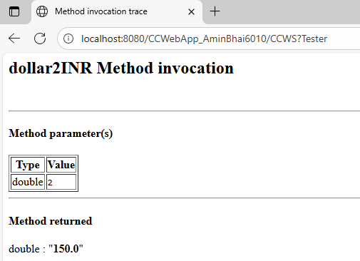
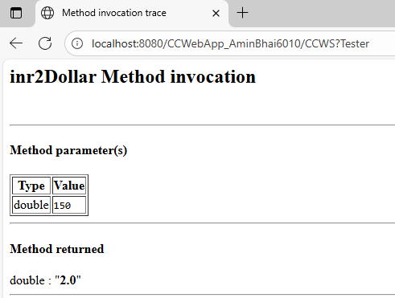

Client-Side Code:-
Input.jsp
<html>
<head>
<meta http-equiv="Content-Type" content="text/html; charset=UTF-8">
<title>JSP Page</title>
</head>
<body>
<form action="output.jsp" method="POST">
Enter The Amount : <input type="text" name="t1" value="" />
<br><br>
Select Conversion Type :
<input type="radio" name="g" value="R2D" />INR To Dollar
<input type="radio" name="g" value="D2R" />Dollar To INR
<br><br>
<input type="submit" value="Submit" />
</form>
</body>
</html>
Output.jsp
<html>
<body>
<%-- start web service invocation --%><hr/>
<%
try {
client.CCWS_Service service = new client.CCWS_Service();
client.CCWS port = service.getCCWSPort();
// TODO initialize WS operation arguments here
double dollar = Double.parseDouble(request.getParameter("t1"));
String type = request.getParameter("g");
if (type.equals("R2D")) {
double result = port.inr2Dollar(dollar);
out.println("Result = " + result);
} else {
// TODO process result here
double result = port.dollar2INR(dollar);
out.println("Result = " + result);
}
} catch (Exception ex) {
// TODO handle custom exceptions here
}
%>
<%-- end web service invocation --%><hr/>
</body>
</html>

Output:-
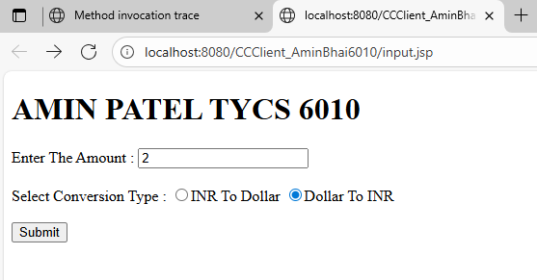

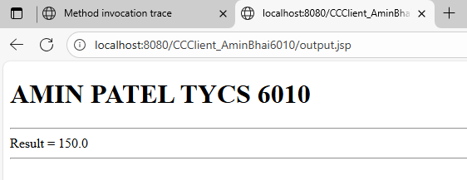
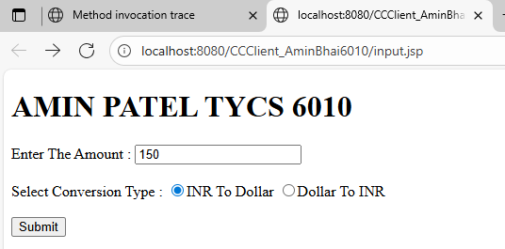

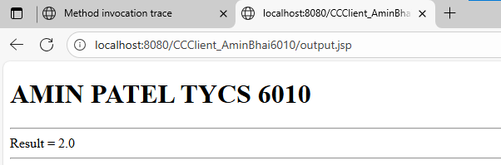

.NET CLIENT:-

CODE:-
using Amin_CC.ServiceReference1;
using System;
namespace Amin_CC
{
internal class Program
{
static void Main(string[] args)
{
Console.WriteLine("AMIN PATEL TYCS 6010");
Console.WriteLine("Enter The Number :");
int amt = Convert.ToInt32(Console.ReadLine());
Console.WriteLine("Enter Conver Type :");
Console.WriteLine("1-D2R \n 2-R2D");
int type = Convert.ToInt32(Console.ReadLine());
CCWSClient obj = new CCWSClient();
if (type == 1)
{
Console.WriteLine("Result =" + obj.Dollar2INR(amt));
}
else
{
Console.WriteLine("Result =" + obj.INR2Dollar(amt));
}
Console.ReadKey();
}
}
}

OUTPUT:-

